

2025
Electronic Toll Collection System (ETCS)
System Design Document version 1.0
Sonali Bank PLC

1. Summary
This document presents the design framework of the Electronic Toll Collection System (ETCS), a solution developed to automate toll fee collection for vehicles traveling through toll plazas. The system is designed to deliver a smooth and efficient transaction lifecycle, encompassing vehicle registration, balance top-up, real-time vehicle passage verification, automatic toll deduction, and secure financial settlement with the appropriate regulatory authorities.

2. Purpose

The primary purpose of this service is to enable automated toll fee collection for vehicles passing through the toll plaza. By implementing an electronic toll collection system, the service aims to reduce traffic congestion, streamline toll operations, and improve overall efficiency and accuracy.

3. Stakeholders
- Vehicle Customers: Vehicle owners who register their vehicles, recharge their accounts, and use the electronic toll collection system while passing through the toll plaza.
- Toll Plaza Authority: The organization responsible for operating, supervising, and managing the toll plaza and its associated electronic toll collection system.
- ETC Registration and Top-Up Bank: The financial institution responsible for electronic toll collection (ETC) registration, virtual account creation, and facilitating top-up services for these accounts.
- Settlement Bank: The financial institution responsible for handling end-of-day financial transactions and executing fund settlements among all relevant parties.

4. Our Strength on Technology

4.1 Commitment of Services:
- Self Payment Service of Customers
- 24x7 services
- Online & sonali e-wallet
- API based Integrations
- Automatic Reconciliation
- Regular Settlement & confirm a-challan / bank account next day
- Real time monitoring panel

4.2 Technical Strength of Sonali Bank PLC:
- High- Availability
- Load Balancers
- WAF
- REST API Integration
- Web based Applications
- Directly API based integrations
- Automated Settlement & Reconciliation

4.3 Technology of Integration and Reconciliation with ETC system:
- Registration and payment transaction through REST API
- Network connectivity (VPN/ IP white list)
- Reconciliation- by shared csv file shared by sftp/portal through VPN/over the.
- daily fund settlement completed t+1 through BEFTN/a-Challan
- API List:
- ETC API
  - Token API
  - Vehicle Checking API
  - Vehicle Registration API
  - Vehicle De-Registration API

- Sonali Bank API
  - Transaction API
  - Transaction Reverse API
- Stakeholder on This Project:
- ETC API system
- Sonali e-Wallet
- Sonali ETC Toll MW API

5. Workflow of ETCS

5.1 Registration & Transaction Flow

Step 1: Vehicle Registration
- The vehicle owner registers online through the Bank’s Electronic Toll Collection System (ETCS).
- The vehicle owner submits required vehicle information, including the RFID tag or vehicle registration number.
- The Bank’s ETCS forwards the registration details to the Toll Plaza System via secure APIs.

Step 2: Vehicle Verification
- The Toll Plaza Vehicle Registration System validates the received vehicle information.
- The system verifies the vehicle’s eligibility for Electronic Toll Collection (ETC).
- Upon successful verification, the Toll Plaza System completes the ETC registration and sends a confirmation to the Bank’s ETCS.

Step 3: Virtual Account Creation
- After receiving vehicle verification confirmation from the Toll Plaza System, the Bank creates a dedicated Virtual Account (A/C) for toll fee recharging.
- The Virtual Account can be recharged through the Bank’s mobile applications, online bill payment portal, or branch counters.
- Virtual Account details are shared with the Toll Plaza System via APIs.
- Once the Virtual Account has a sufficient balance, the vehicle becomes eligible to use ETC lanes at the toll plaza.

Step 4: Toll Fee Recharge
- The vehicle owner tops up the Virtual Account using the Bank’s mobile app, online bill payment portal, or branch counters.
- The Bank’s ETCS validates the available balance and confirms ETC lane eligibility
- The vehicle owner can view the available balance through the bank application.
- The vehicle owner may request a refund of any unused balance to a bank account held with any bank in Bangladesh.

Step 5: Vehicle Passage through ETC Lane
- When the vehicle enters the ETC lane at the toll plaza, sensors and RFID readers detect the vehicle in real time.
- The Toll Plaza System validates vehicle registration status, payment institution, and associated Virtual Account.
- A toll charge authorization request is sent to the Bank’s ETCS for confirmation.

Step 6: Toll Fee Deduction
- The Bank’s ETCS verifies the available balance in the vehicle owner’s Virtual Account.
- Upon successful verification, the Bank’s ETCS sends an authorization response to the Toll Plaza System.
- The toll fee is deducted from the Virtual Account within the defined transaction time (e.g., within 5 seconds).

Step 7: Vehicle Pass Confirmation
- Upon receiving transaction confirmation from the Bank’s ETCS, the Toll Plaza System opens the gate and allows the vehicle to pass through the ETC lane.
- The vehicle owner receives an SMS notification confirming the toll fee deduction.

Step 8: Toll Fee Reversal
- If a vehicle fails to pass through the ETC lane after toll fee deduction has been authorized, the Toll Plaza System initiates a reversal request to the Bank’s ETCS.
- The Bank’s ETCS validates the transaction and refunds the deducted toll fee to the vehicle owner’s Virtual Account.
- The reversal confirmation is sent back to the Toll Plaza System.

Step 9: Balance Inquiry
- The vehicle owner can check the remaining balance of the Virtual Account at any time through the bank’s mobile or online banking application.

Step 10: Vehicle De-Registration
- The vehicle owner submits a de-registration request online through the Bank’s ETCS.
- Required vehicle details, including the RFID tag or vehicle registration number, are provided.
- The Bank’s ETCS forwards the de-registration request to the Toll Plaza System via APIs.
- Upon successful processing, de-registration is confirmed by the Toll Plaza System.

5.2 Settlement Flow

Step 1: Bank Reconciliation
- The bank collects all recharge transactions and confirms the amounts to the Bank’s ETCS system.

Step 2: End-of-Day Settlement
- At the end of the day, the bank transfers the collected toll funds to the Toll Plaza Authority’s bank account at sonali bank PLC , also use a-Challan.

6. System Components

6.1 Hardware Components ( Basic information of Toll Plaza system)
- RFID Tags: Installed on registered vehicles for identification.
- RFID Readers & Sensors: Installed at toll collection points to capture vehicle details.
- Toll Gate Barriers: Automatically open upon successful toll fee deduction.
- CCTV Cameras: Capture vehicle images for security and verification.
- Centralized Server: Hosts the ETCS backend and manages all transactions.

6.2 Software Components
- Bank’s ETCS: Used for vehicle registration, recharge, toll fee deduction and balance inquiry.
- ETCS Backend System: Manages vehicle verification, and transaction records.
- Notification Service: Sends SMS alerts for successful transactions.
- Bank’s ETCS Gateway: Facilitates communication between banks, the toll collection system, and the settlement system.
- Database Management System: Stores user details, transaction history, and vehicle records.

7. Security Considerations
- Data Encryption: Ensures secure and encrypted communication among the Bank, the Electronic Toll Collection System (ETCS), and the Toll Plaza Authority to protect sensitive data.
- Multi-Factor Authentication (MFA): Implements strong user authentication mechanisms, including One-Time Passwords (OTP), to secure user access and vehicle registration processes.
- Fraud Detection System: Monitors and analyzes transactions in real time to detect suspicious activities and prevent unauthorized vehicle access or fraudulent toll transactions.

8. Flow Diagram

1. Vehicle Registration Flow Diagram

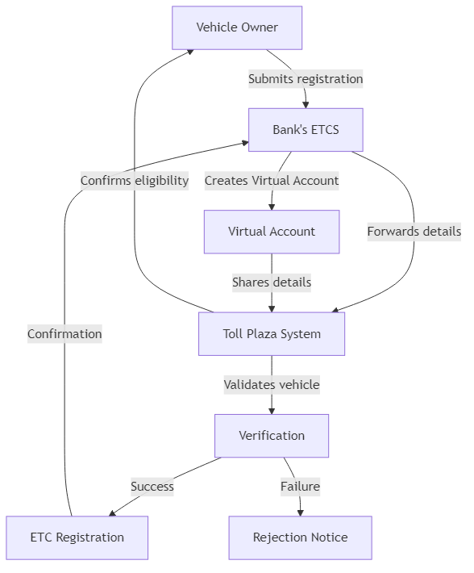

2. Vehicle De-Registration Flow Diagram

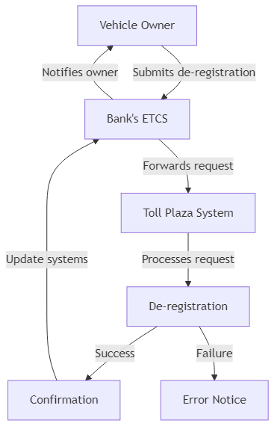

3. Vehicle Top-up Flow Diagram

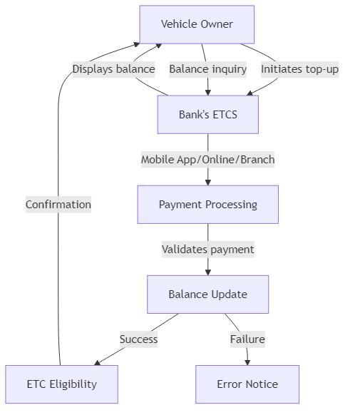

4. Toll Plaza Pass Flow Diagram 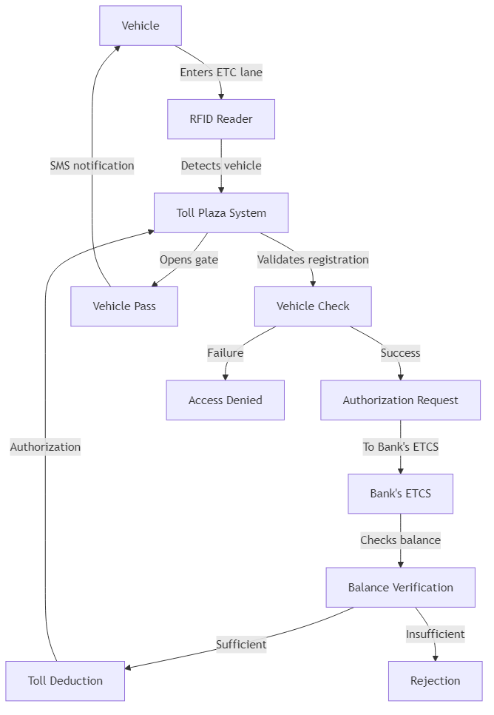

5. Settlement Flow Diagram

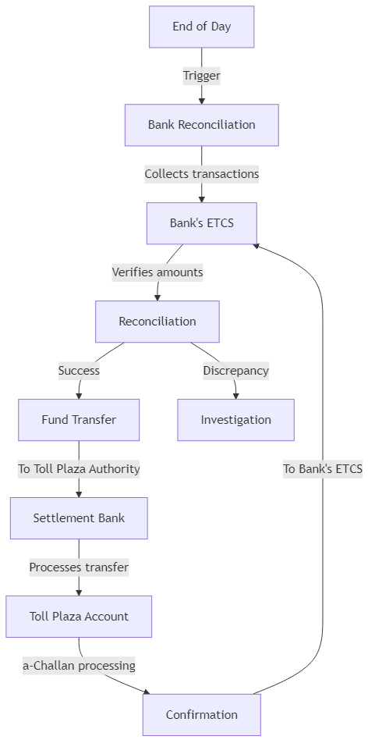

9. Network Diagram
Toll Plaza System
Bank’s App/Web/Counter
Bank’s ETCS
Ver. Owner

Vehicle

10. Performance Considerations
- Real-Time Processing: Ensures vehicle validation and toll fee deduction are completed within 2–3 seconds to support smooth traffic flow.
- Scalability: Designed to handle a growing number of registered vehicles and increasing transaction volumes without performance degradation.
- High Availability: Ensures continuous system operation through redundant infrastructure, failover mechanisms, and proactive monitoring to minimize downtime.

11. Conclusion
The Electronic Toll Collection System (ETCS) is designed to deliver a seamless and fully automated toll collection solution that enhances traffic flow, strengthens security, and ensures financial transparency. Through robust bank integration, real-time vehicle identification, and automated toll fee deduction and settlement processes, the system provides an efficient, reliable, and scalable approach to toll plaza operations.

Thank’s

